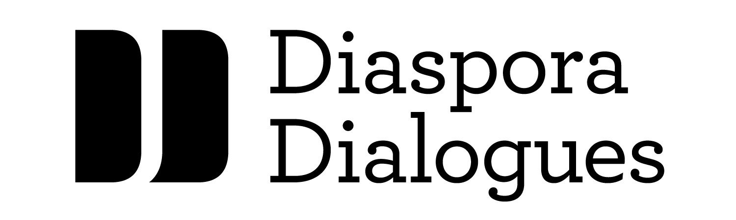
Diaspora Dialogues National Mentoring Program

Open Call Application Form, 2020

Please print clearly and complete in full.

Name: _______________________________________________________________________

Address: _____________________________________________________________________

Phone number: _______________________________________________________________

Title: ________________________________________________________________________

Type of work: □ Novel □ Short story collection □ Poetry collection

Submission Checklist

□ Completed submission form

□ Sample from a manuscript at full draft, or near full draft, stage

□ Short biographical paragraph

□ One-page description of the work

Total page count of submission (including this page): ____________

Please email submissions by Friday, October 16, 2020 to: zalika@diasporadialogues.com by 11:59 EST

